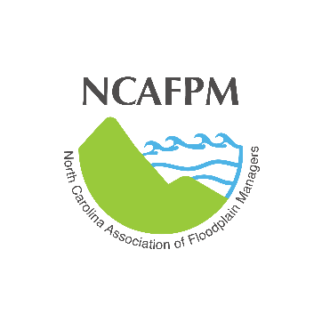
30th ANNUAL CONFERENCE
NORTH CAROLINA ASSOCIATION OF FLOODPLAIN MANAGERS

May 5-8, 2019
Holiday Inn Resort
Wrightsville Beach, NC

CALL FOR PRESENTATION ABSTRACTS

The North Carolina Association of Floodplain Managers (NCAFPM) will host our annual conference in May.

This Call for Abstracts seeks a broad range of professions to address the many issues and problems associated with reducing flood damages, making communities more sustainable and managing floodplain and fragile coastal resources.
Suggested topic areas include:
- Floodplain Mapping
- GIS - LIDAR - Other Technologies
- Hazard Mitigation Planning
- Mitigation Success Stories
- Coastal Resources and Resiliency
- Coastal and Estuarine Science
- Stream Channel/Wetlands Restoration
- NFIP and Floodplain Management
- Integration of Floodplain Management with other fields
  - i.e. Planning, Recreation, Open Space Preservation, Stormwater Management, Public Health, Emergency Management
- Recent Flood Events/Lessons Learned
- Storm Water Programs/Funding
- Hydrologic/Hydraulic Modeling
- CRS
- Local Building Code Issues
- Legal Issues
- Conflict Resolution
- Community Relations
- Other Related Topics

Please select from one of the following session types.

Session Format Types:

Traditional Educational Session
Propose a 20-minute session from any of the suggested topic areas. Typically, these sessions combine 3 speakers on common topics with a 5-minute Q & A time for each speaker.

Deep Dive Session
Propose a 45-minute session from any of the suggested topic areas. This session is intended to cover an in-depth topic and allow more interaction and time for attendees to ask questions and discuss relevant topics. This deep dive session could be in a traditional speaker format or panel discussion format.

Lightning Round Session
Propose a 10-minute session from any of the suggested topic areas. These sessions are intended to be lively and informative talks from several presenters in a 90-minute session format with 15 minutes for Q&A.

Abstract Submission:
If you are interested in presenting a topic, please e-mail the Abstract Submission Form, available on the NCAFPM website, to David Goode at David.Goode@MeckNC.gov.
- Title of presentation
- Type of session
- Brief abstract of your presentation (a sample can be found on our website)
- Name of presenter(s)
- Brief biography of each presenter
- Affiliation
- Address
- Telephone Number
- E-mail Address
Abstracts should be submitted prior to March 22, 2019. Presenters will be notified of acceptance by March 29, 2019. Presenters should be prepared to speak for their entire allotted time.

For questions on abstract submissions contact program co-chairs:

David Goode: David.Goode@MeckNC.gov
980.314.3235

Holly White: holly.white@nagsheadnc.gov
252.449.6041

