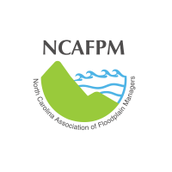
NCAFPM Conference Abstract Submittal Form

Today’s date: Click or tap to enter a date.

 | Traditional Educational Session | Propose a 30-minute presentation of any of the suggested topic areas. This 30-minute time slot will include speaker introduction(s), presentation, and 5 minutes of Q&A. Three 30-minute presentations will be combined into 90-minute concurrent session blocks.
Title of your Presentation |  | Click or tap here to enter text.
Brief abstract of your presentation. |  | Click or tap here to enter text.
Name of presenter(s). Please list the complete name with credentials for each presenter. This is how the names will appear on the program. |  | Click or tap here to enter text.
Brief biography of each presenter. Please type all presenter Bio’s in this area separated by hard return. |  | Click or tap here to enter text.
 |  | The following information should be for the “Lead Presenter” as the main contact.
Affiliation |  | Click or tap here to enter text.
Address |  | Click or tap here to enter text.
Telephone number |  | Click or tap here to enter text.
E-mail address |  | Click or tap here to enter text.
Please be sure to provide complete information on each area. Incomplete submissions will be returned. Save the document as a .docx file format to preserve the template for future use. Please email the completed document to abstracts@ncafpm.org

